Steps to run this Example to remove the Duplicate Array Elements:

1 – Right click → Run As → Java Application
Provide any input type in Console

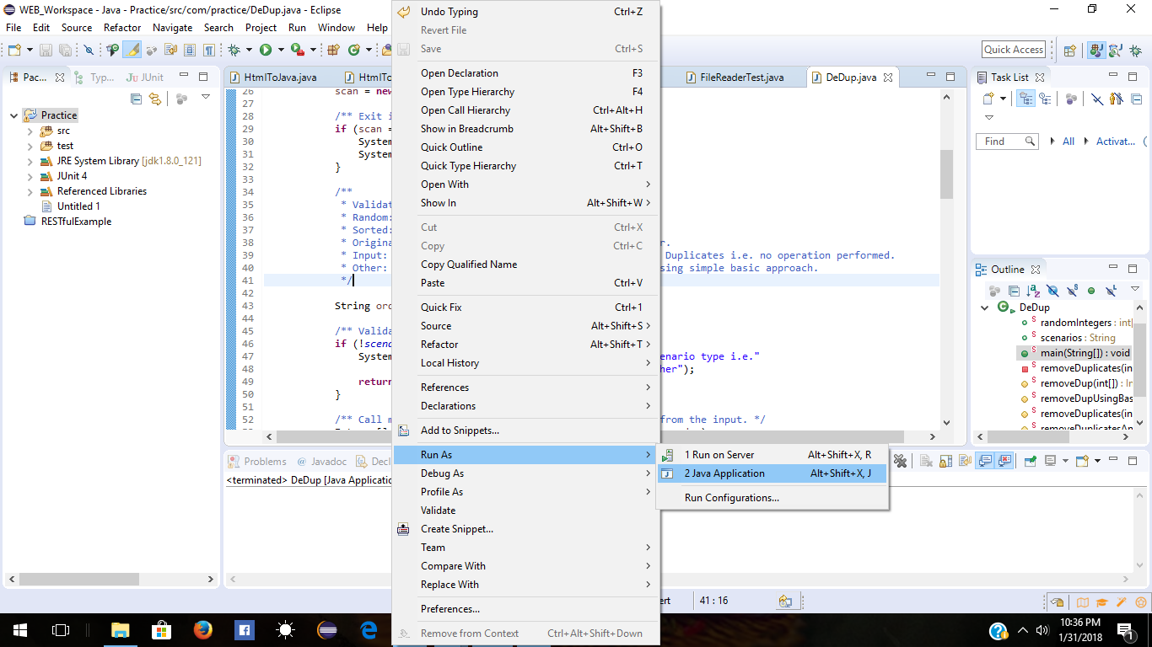
OR

1 - Right click → Run As → Run Configurations
Provide any input type in Command Line Arguments

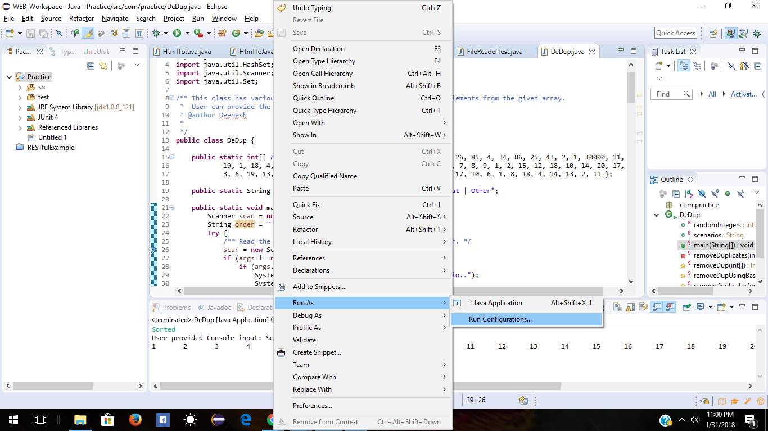
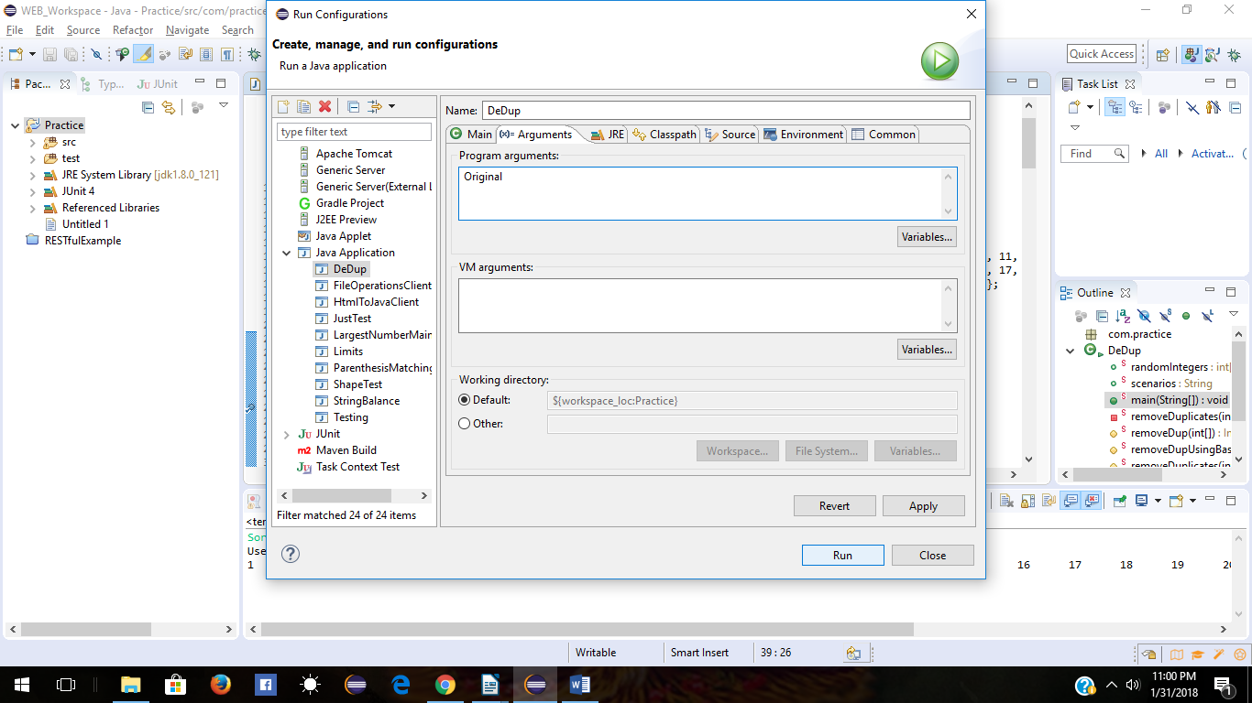

2 – Provide any input value like Random or Sorted or Original and hit Enter.
3 – This program will take user input and provide the expected output i.e. Unique array elements or same as source array.
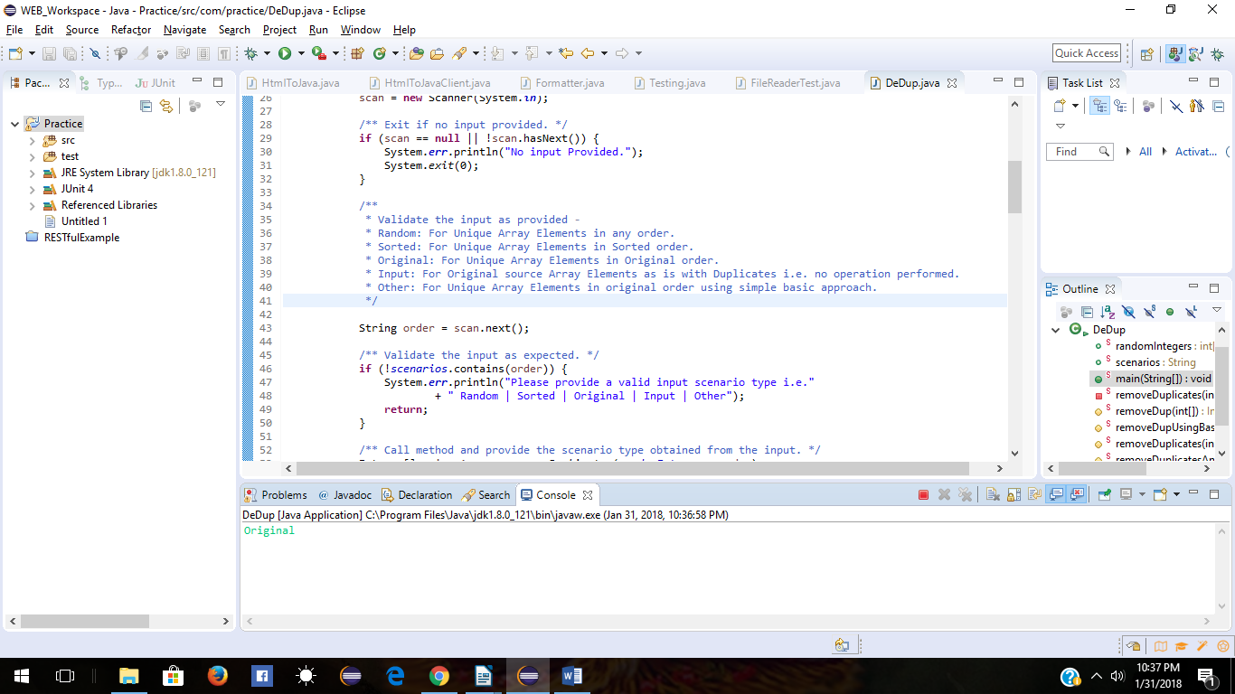
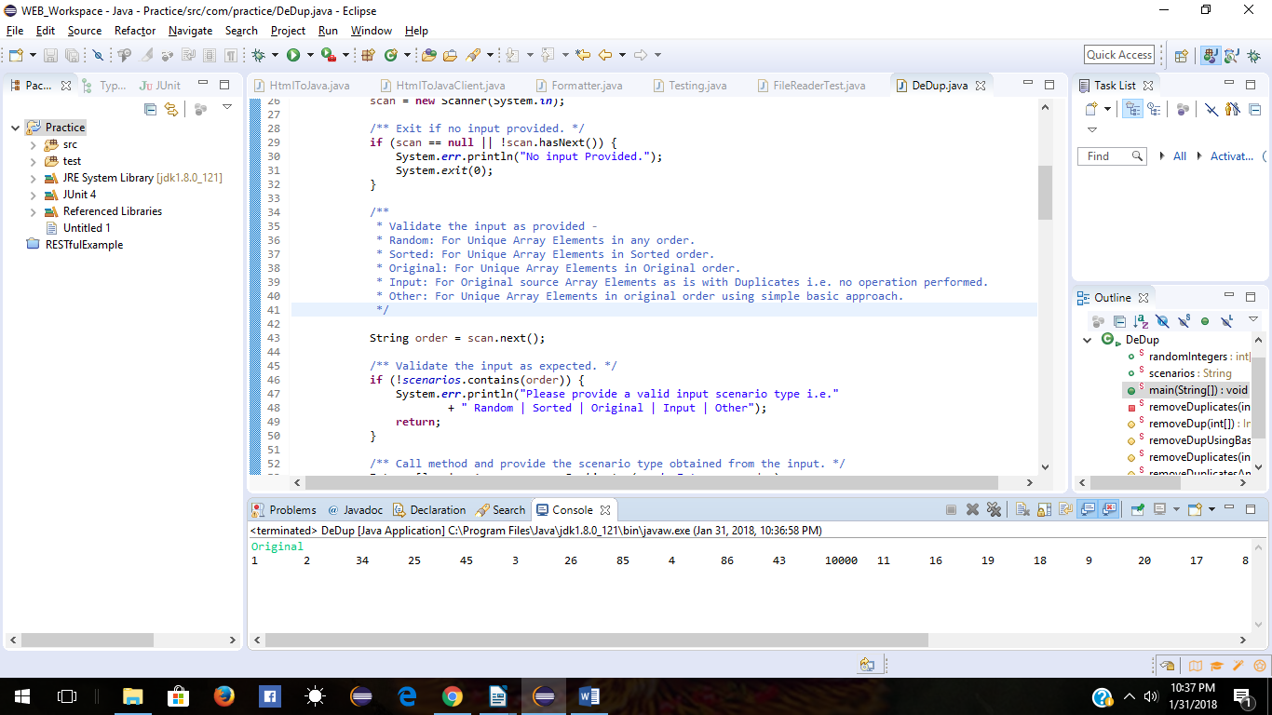
Original

Sorted
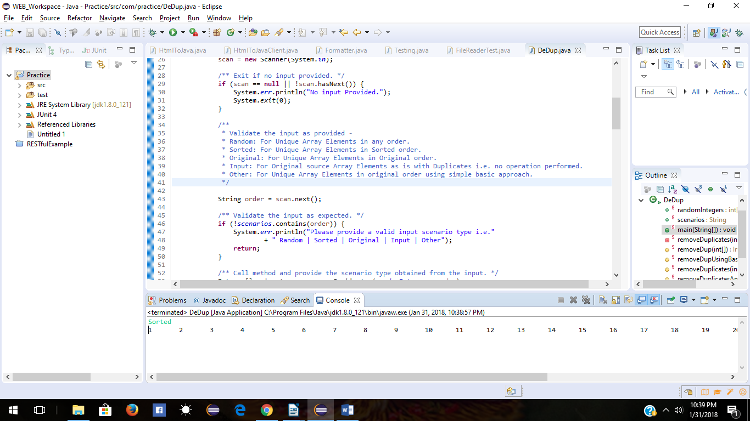
Input – To print as it is source
